
National
University
of
Computer
and
Emerging
Sciences
Chiniot-Faisalabad
Campus
CL2001 – Data Structures - Lab
Lab 7
“Queues Variations and Recursion”
Fall 2024
Maximum Marks: 100 Due Date: 04 October 2024
Submitted By
Name: | Talha Abdullah
Student ID: | 22F-3194
Section: | BAI-3A
Submitted To
Muhammad Yousaf
Lecturer – AI & Data Science Department
Submission Date
04 October 2024
Table of Contents
Question / Title ................................................................................................................ Page Number
Problem 1............................................................................................................................................... 2
Source Code........................................................................................................................................2
Screenshot..........................................................................................................................................5
Problem 2............................................................................................................................................... 5
Source Code........................................................................................................................................5
Screenshot..........................................................................................................................................5
Problem 3............................................................................................................................................... 5
Source Code........................................................................................................................................5
Screenshot........................................................................................................................................ 10
Problem 4............................................................................................................................................. 7
Source Code...................................................................................................................................... 9
Screenshot........................................................................................................................................

Problem 1

Source Code
#include <iostream>
using namespace std;

class Queue {
private:
struct node {
int value;
node* next;
};
node* front;
node* rear;
int numItems;

public:
Queue();
~Queue();
bool isEmpty();
void makeNull();
void push(int);
bool pop(int&);
void top();
void display();
};

Queue::Queue() {
front = NULL;
rear = NULL;
numItems = 0;
}

Queue::~Queue() {
makeNull();
}

bool Queue::isEmpty() {
return front == NULL;
}

void Queue::push(int num) {
node* newNode = new node;
newNode->value = num;
newNode->next = NULL;

if (isEmpty()) {
front = rear = newNode;
}
else if (num >= front->value) {
newNode->next = front;
front = newNode;
}
else {
node* temp = front;
while (temp->next != NULL && temp->next->value > num) {
temp = temp->next;
}
newNode->next = temp->next;
temp->next = newNode;
if (newNode->next == NULL) {
rear = newNode;
}
}
numItems++;
}

bool Queue::pop(int& num) {
if (isEmpty()) {
cout << "The queue is empty." << endl;
return false;
}

num = front->value;
node* temp = front;
front = front->next;
delete temp;

if (front == NULL) {
rear = NULL;
}

numItems--;
return true;
}

void Queue::top() {
if (!isEmpty()) {
cout << "Max priority element is: " << front->value << endl;
}
else {
cout << "The queue is empty." << endl;
}
}

void Queue::display() {
if (isEmpty()) {
cout << "The queue is empty." << endl;
return;
}

node* temp = front;
cout << "Queue elements: ";
while (temp != NULL) {
cout << temp->value << "->";
temp = temp->next;
}
cout << endl;
}

void Queue::makeNull() {
int x;
while (!isEmpty()) {
pop(x);
}
}

int main() {
Queue pq;
int choice, value;

while (true) {
cout << "------------Menu------------" << endl;
cout << "1. Push (Insert value)" << endl;
cout << "2. Pop (Remove Max priority value)" << endl;
cout << "3. Top (Display Max priority value)" << endl;
cout << "4. Display all elements in the queue" << endl;
cout << "0. Exit the program" << endl;
cout << "Enter a value to select an option: ";
cin >> choice;

switch (choice) {
case 1:
cout << "Enter a value to insert: ";
cin >> value;
pq.push(value);
break;
case 2:
if (pq.pop(value)) {
cout << "Removed Max priority value: " << value << endl;
}
break;
case 3:
pq.top();
break;
case 4:
pq.display();
break;
case 0:
cout << "Exiting program..." << endl;
return 0;
default:
cout << "Invalid choice! Please try again." << endl;
break;
}
}

return 0;
}

Screenshot
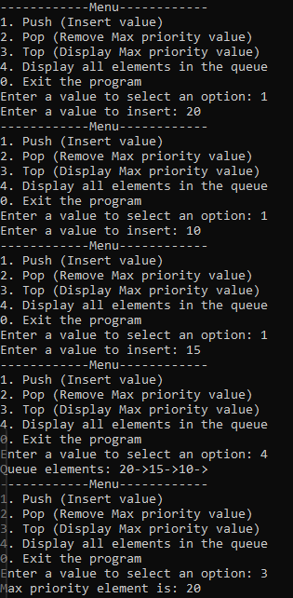

Problem 2

Source Code

Screenshot

Problem 3

Source Code
#include <iostream>
#include <string>
using namespace std;

class Process {
public:
string type;
int priority;
Process(string t, int p) : type(t), priority(p) {}
};

class Queue {
private:
struct node {
Process* process;
node* next;
};
node* front;
node* rear;
int numItems;

public:
Queue();
~Queue();
bool isEmpty();
void makeNull();
void push(Process*);
bool pop(Process*&);
void top();
void display();
};

Queue::Queue() {
front = NULL;
rear = NULL;
numItems = 0;
}

Queue::~Queue() {
makeNull();
}

bool Queue::isEmpty() {
return front == NULL;
}

void Queue::push(Process* process) {
node* newNode = new node;
newNode->process = process;
newNode->next = NULL;

if (isEmpty()) {
front = rear = newNode;
}
else if (process->priority <= front->process->priority) {
newNode->next = front;
front = newNode;
}
else {
node* temp = front;
while (temp->next != NULL && temp->next->process->priority < process->priority) {
temp = temp->next;
}
newNode->next = temp->next;
temp->next = newNode;
if (newNode->next == NULL) {
rear = newNode;
}
}
numItems++;
}

bool Queue::pop(Process*& process) {
if (isEmpty()) {
cout << "The queue is empty." << endl;
return false;
}

process = front->process;
node* temp = front;
front = front->next;
delete temp;

if (front == NULL) {
rear = NULL;
}

numItems--;
return true;
}

void Queue::top() {
if (!isEmpty()) {
cout << "Process Type: " << front->process->type << ", Priority: " << front->process->priority << endl;
}
else {
cout << "The queue is empty." << endl;
}
}

void Queue::display() {
if (isEmpty()) {
cout << "The queue is empty." << endl;
return;
}

node* temp = front;
cout << "Queue elements: ";
while (temp != NULL) {
cout << "[" << temp->process->type << ": " << temp->process->priority << "] -> ";
temp = temp->next;
}
cout << "NULL" << endl;
}

void Queue::makeNull() {
Process* tempProcess;
while (!isEmpty()) {
pop(tempProcess);
}
}

class MultiLevelQueue {
private:
Queue systemQueue;
Queue userQueue;

public:
void push(string type, int priority);
void pop(string type);
void top(string type);
void displayAll();
};

void MultiLevelQueue::push(string type, int priority) {
Process* newProcess = new Process(type, priority);
if (type == "System") {
systemQueue.push(newProcess);
}
else if (type == "User") {
userQueue.push(newProcess);
}
else {
cout << "Invalid process type! Please use 'System' or 'User'." << endl;
delete newProcess;
}
}

void MultiLevelQueue::pop(string type) {
Process* process = nullptr;
if (type == "System") {
if (systemQueue.pop(process)) {
cout << "Removed process with Type: " << process->type << ", Priority: " << process->priority << endl;
delete process;
}
}
else if (type == "User") {
if (userQueue.pop(process)) {
cout << "Removed process with Type: " << process->type << ", Priority: " << process->priority << endl;
delete process;
}
}
else {
cout << "Invalid process type! Please use 'System' or 'User'." << endl;
}
}

void MultiLevelQueue::top(string type) {
if (type == "System") {
cout << "System Queue Top: ";
systemQueue.top();
}
else if (type == "User") {
cout << "User Queue Top: ";
userQueue.top();
}
else {
cout << "Invalid process type! Please use 'System' or 'User'." << endl;
}
}

void MultiLevelQueue::displayAll() {
cout << "System Queue: " << endl;
systemQueue.display();
cout << "User Queue: " << endl;
userQueue.display();
}

int main() {
MultiLevelQueue mlqArray[5];
int choice, priority, queueIndex;
string type;

while (true) {
cout << "------------Menu------------" << endl;
cout << "1. Push (Insert process)" << endl;
cout << "2. Pop (Remove process by type)" << endl;
cout << "3. Top (Display top process by type)" << endl;
cout << "4. Display all processes in a specific queue" << endl;
cout << "0. Exit the program" << endl;
cout << "Enter a value to select an option: ";
cin >> choice;

switch (choice) {
case 1:
cout << "Enter queue index (0-4): ";
cin >> queueIndex;
if (queueIndex < 0 || queueIndex >= 5) {
cout << "Invalid queue index! Please enter a value between 0 and 4." << endl;
break;
}
cout << "Enter process type (System/User): ";
cin >> type;
cout << "Enter process priority: ";
cin >> priority;
mlqArray[queueIndex].push(type, priority);
break;
case 2:
cout << "Enter queue index (0-4): ";
cin >> queueIndex;
if (queueIndex < 0 || queueIndex >= 5) {
cout << "Invalid queue index! Please enter a value between 0 and 4." << endl;
break;
}
cout << "Enter process type to remove (System/User): ";
cin >> type;
mlqArray[queueIndex].pop(type);
break;
case 3:
cout << "Enter queue index (0-4): ";
cin >> queueIndex;
if (queueIndex < 0 || queueIndex >= 5) {
cout << "Invalid queue index! Please enter a value between 0 and 4." << endl;
break;
}
cout << "Enter process type to view top (System/User): ";
cin >> type;
mlqArray[queueIndex].top(type);
break;
case 4:
cout << "Enter queue index (0-4) to display: ";
cin >> queueIndex;
if (queueIndex < 0 || queueIndex >= 5) {
cout << "Invalid queue index! Please enter a value between 0 and 4." << endl;
break;
}
mlqArray[queueIndex].displayAll();
break;
case 0:
cout << "Exiting program..." << endl;
return 0;
default:
cout << "Invalid choice! Please try again." << endl;
break;
}
}

return 0;
}

Screenshot
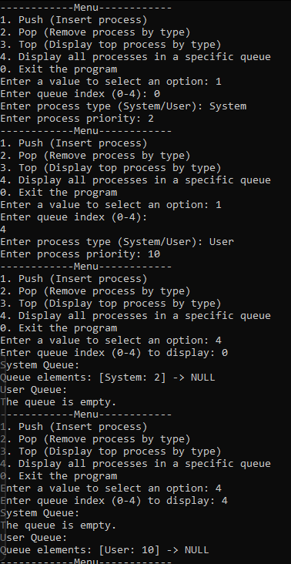

Problem 4

Source Code

Screenshot

